Thank-you for downloading the
Security Risk Management Plan Template!

More templates to download on the:

Templates Repository for Software Development Process (click here)

Or paste the link below in your browser address bar:
http://blog.cm-dm.com/pages/Software-Development-Process-templates

This work is licensed under the:
Creative Commons Attribution-NonCommercial-NoDerivs 3.0 France License: http://creativecommons.org/licenses/by-nc-nd/3.0/fr/

Waiver:
You can freely download and fill the templates of blog.cm-dm.com, to produce technical documentation. The documents produced by filling the templates are outside the scope of the license. However, the modification of templates to produce new templates is in the scope of the license and is not allowed by this license.

To be compliant with the license, I suggest you to keep the following sentence at least once in the templates you store, or use, or distribute:
This Template is the property of Cyrille Michaud License terms: see http://blog.cm-dm.com/post/2011/11/04/License

Who am I? See my linkedin profile:
http://fr.linkedin.com/pub/cyrille-michaud/0/75/8b5

You can remove this first page when you’ve read it and acknowledged it!

TABLE OF CONTENTS
1 Introduction 2
1.1 Document overview 2
1.2 References 2
1.2.1 Project References 2
1.2.2 Standard and regulatory References 2
1.2.3 Standard and regulatory References 3
2 Responsibilities 3
3 Risk management process 4
3.1 Context establishment 4
3.2 Risk assessment 6
3.2.1 Identification 6
3.2.2 Analysis 7
3.2.3 Evaluation 8
3.3 Risk treatment 8
3.4 Risk acceptance 8
3.5 Risk communication 8
3.6 Post-production monitoring and review 8
4 Ranking system for security risk analysis 9
4.1 Probability of occurrence 9
4.2 Severity 9
4.3 Other criteria 10
4.4 Risk Priority Number 10
5 Relationships with safety risk management 10
5.1 Communication with safety risk management team 10
5.2 Communication with usability engineering team 11

Introduction

Document overview
Describe the purpose of the document
This document contains the security risk management plan for XXX device. It covers the management all security-related risks during the lifecycle of the device, in design and development, and in maintenance. It also contains the provisions about relationships with the ISO 14971 safety risk management process, and IEC 62366-1 usability engineering process.

References

Project References

# | Document Identifier | Document Title
[R1] | ID | Add your documents references.  One line per document

Standard and regulatory References

# | Document Identifier | Document Title
[STD1] |  | Add your documents references.  One line per document

Add the standard references to the table above. It may include ISO 14971, ISO 13485, IEC 62304, IEC 80001-1, ISO 2700x, AAMI TIR 57, UL 2900-1 amongst others.
Add FDA guidances: Content of Premarket Submissions for Management of Cybersecurity in Medical Devices – October 2014, Postmarket Management of Cybersecurity in Medical Devices – December 2016.

Definitions
Information security risk: potential that a given threat will exploit vulnerabilities of an asset or group of assets, and thereby cause harm to the organization.
You may add here other definitions like Asset, Threat, Vulnerability found in ISO 27005.

Conventions
Security risk and Cybersecurity risk are used indifferently in this document as synonyms of Information security risk according to the definition above.

Responsibilities
Describe the organization of the team responsible for risk management. You may add an organization chart or add a reference to your project management plan, where the organization of the project should be already described.

Either describe the responsibilities in plain text:
The security risk manager is in charge of the security risk. The Quality and regulatory manager is in charge of the relationships with the ISO 14971 safety risk management process.

Or use a table
Person | Responsibility
Security Officer | - Overall risk management process responsibility
Project Manager | - Risk management process responsibility during design
Hardware design manager | - Hardware security risks
System design manager | - System / network security risks
Software design manager | - Software security risks
Quality Manager | - Independent review of Risk Management File
Quality Manager | - Interface with the safety risk management process
Deployment Manager | - Interface with IT services in healthcare center
Customer Service Manager | - Interface with end-users in healthcare center

You may also explain here how adverse events are escalated in the organization. Eg: Adverse events or risk of adverse events detected throughout the organization shall be immediately reported to the security officer.

Risk management process
The process described below is inspired form the risk management process presented in ISO 27005 (which stems from risk management process presented in ISO 31000), with arrangements for medical device manufacturers.
The risk management process is an iterative process allowing to increase the depth and details of risk assessment at each iteration.

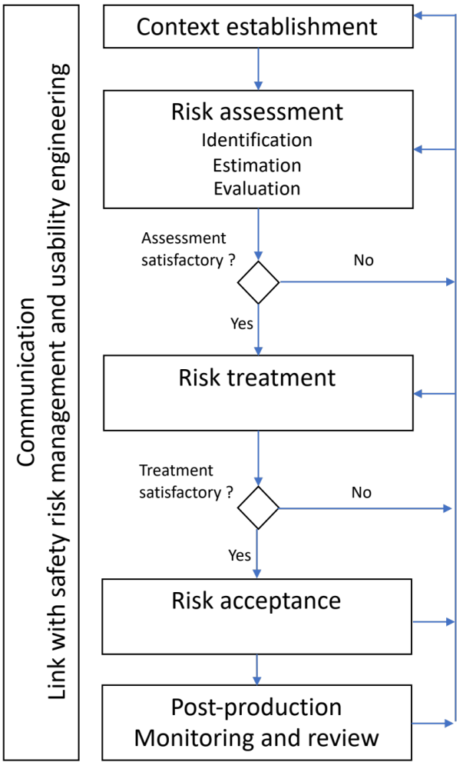

Context establishment
Establishing the context consists in defining the scope and boundaries, and describing the following items, as appropriate:
- The medical device (hardware, software, network…)
- Its accessories,
- Its environment
  - Operating room
  - Patient room
  - At home
- Other connected devices,
  - Medical devices,
  - Non-medical devices,
  - Cloud servers
- The processes involved in the lifecycle of the device:
  - Internal processes,
  - Outsourced processes and
  - Client/user processes,
- The users and user profiles
  - Client users,
  - Users of the manufacturer (e.g. customer support)
- The level of education of users,
- The use cases associated to the users and user profiles,
- The types of data handled in the device
  - Medical and personal data,
  - Data from sensors,
  - Configuration data,
  - Logs
- The hardware network interfaces
  - Bluetooth,
  - Wifi, Zigbee,
  - RJ45,
- The software network interfaces and protocols
  - HTTP, TCP, UDP,
  - SOAP, REST
  - Network Ports
- The data input/output streams
  - With connected devices,
  - Through removable media,
  - Internally between sub-systems of the device,
- The COST/SOUP used in software
- The constraints affecting the device
  - On the device,
  - On manufacturer processes,
  - On user processes, E.g. end-users generally don’t accept to un-scrub and scrub for IT security reasons,
  - Regulatory requirements: GDPR, HIPAA…
- Constraints regarding emergency access to the device for patient safety, bypassing security measures.

All items listed above in 2nd level bullets are practical examples, other cases may be applicable to the device.

This context establishment can be described in a mind maps, use cases, hardware architecture, system architecture, software architecture, as appropriate.

Some information may already be documented in the IEC 62336-1 usability engineering file. E.g. Users, user profiles, use cases.

The constraint of emergency access to the device, bypassing security measures, shall be described in the context.

Additionally, the manufacturer shall provide justification for any exclusion from the scope.

Risk assessment
Based on the context documented in the previous step, the risks shall be identified, analysed and evaluated according to the objectives of the risk management process and the ranking system for security risk analysis.

A preliminary risk assessment may be documented at the beginning of the design project, or before design (e.g. in feasibility / mock-up etc.) and reviewed in the design input data.

Identification
The steps of security risk identification are the following:
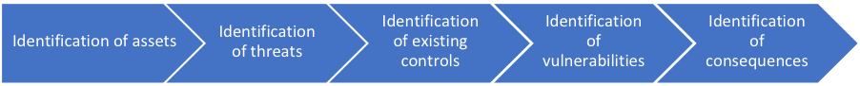

Assets
An asset is anything of value for the manufacturer or for the end-user.
Assets can be:
- Hardware,
- Software,
- Data,
- Other tangible or intangible assets.

Examples:
- The medical device itself,
- Its accessories,
- Devices connected to the medical device,
- Cloud servers,
- Patient data,
- Other data.

Knowing the assets contributes to identify the magnitude of the consequences of adverse event. Eg: the consequences won’t have the same order of magnitude if the device is a simple object, a cloud server, or a $1M x-ray scanner.

You may reference here the list of assets in annex B of AAMI TIR 57 or annex B of ISO 27005 as a help to identify assets.

Threats
A threat is anything (human, phenomenon, accidental, deliberate) susceptible to result in a damage on one or more assets.
Examples:
- Script kiddies
- Academic researchers
- Criminal organizations
- Inexperienced users
- Natural events

You may reference here the list of threats in annex B of AAMI TIR 57 or appendix C of ISO 2005 as a help to identify threats.

Existing controls.
Existing or planned controls should be identified. They can be identified inside the manufacturer’s organization or in the target environments or other environments (healthcare provider, datacenter service supplier…).
Existing or planned controls should be assessed to determine if they are effective, sufficient and justified.

Vulnerabilities
Vulnerabilities shall be identified. Vulnerabilities may come from design decisions, misuse of the device, software SOUPs, organizations, processes, etc.
Vulnerabilities can be found in catalogs like the Common Vulnerabilities and Exposures List, the National Health ISAC and release notes of SOUP /COTS editors.

You may reference here the annex B of AAMI TIR 57 or appendix D of ISO 2005 as a help to identify vulnerabilities.

Consequences
The consequences that loss of confidentiality, integrity and availability may have on the assets shall be identified. The consequences on patient safety shall also be identified.

You may reference here the section Impact Assessment of annex B of AAMI TIR 57 or appendix B.3 of ISO 2005 as a help to identify consequences.

Records
Assets, threats, vulnerabilities, existing controls and consequences shall be recorded in the security risk assessment report.

Analysis
The risk analysis is performed with the use of the ranking system described in section 4 of this document, and with the data collected in the previous steps:
- The identification of the consequences on assets allow to determine the impact magnitude of the risk,
- The identification of threats, vulnerabilities, and incident scenarios allow to determine the likelihood of a risk.

Records
For each incident scenario: probability of occurrence, severity, other criteria, and RPN are recorded in the risk assessment report.

Evaluation
The RPN are compared against risk acceptance criteria described in section 4. Legal and regulatory requirements shall be included in the evaluation of the acceptance of risks.

Records
For each incident scenario: risk acceptance, and decision.

Risk treatment
The term “risk treatment” is used in ISO 27005. Note that the meaning of “risk treatment” is broader than “risk control” or “risk mitigation” commonly used in medical device industry.

Risk treatment options are:
- Risk modification or risk control,
- Risk retention,
- Risk avoidance,
- Risk sharing.

Risk controls shall be sought in this order of precedence:
- Security by design,
- Security measures implemented in production or servicing,
- Information for security.

Risk control should be carried out to decrease the RPN of the residual risk As Low As Reasonably Possible (ALARP), with economic considerations. If the risk has an impact on patient safety, the risk treatment (risk control) shall be carried out with acceptance criteria related to patient safety.

The security vulnerabilities or impacts on patient safety arising from risk treatment shall also be assessed.

Records
For each incident scenario: the risk treatment plan.

Risk acceptance
The reevaluation of the risk is performed with the use of the ranking system described in section 4 of this document, and with the risk treatment plan.

A security risk may be deemed accepted even if it doesn’t match the risk acceptance criteria of section 4, with justification to override the acceptance criteria.

Records
For each incident scenario: the risk acceptance and justification as appropriate.

Risk communication
The risk assessment report is communicated internally to the design team. The risk assessment report shall be an agenda item of design reviews, and validation reviews.

Parts of the risk assessment report may also be communicated externally to service providers or suppliers, as appropriate. When a supplier requires knowledge of the risk assessment report, it should be determined if this supplier shall be placed in the list of critical suppliers.

Add also the need to communication to ISAC ISAO, per FDA guidance on cybersecurity, if needed.

Post-production monitoring and review
The Risk Management File is systematically reviewed and updated, especially when:
- The product is modified,
- The context changes,
- Assets, threats, vulnerabilities change,
- Analysis of data of post marketing surveillance triggers a reevaluation (internal defects, customer requests, maintenance, vigilance bulletins, security incidents, field information from any source).

The review of post-marketing data is performed quarterly / annually / other period. Reviews and updates to any risk will be documented, approved, and included within the Risk Management File.

The review includes an evaluation of the relevance of the ranking system and the need to update it upon business or regulatory context.

Ranking system for security risk analysis
This section describes how the risk priority number is deduced from the characteristics of the risk:
- Probability of occurrence,
- Severity of consequences
- Other criteria (if any).

Describe in sub sections how you quantify your criteria, like these:

Probability of occurrence
Use quantitative or qualitative criteria. Here is an example.

Ranking | Definition | Probability (P)
5 | Often occurs, once a week | Frequent (very high probability)
4 | Could easily happen, once a month | Probable (high probability)
3 | Could happen or known to happen, once a year | Occasional (moderate probability)
2 | Hasn’t happened yet but could, once in device lifetime | Unlikely (low probability)
1 | Conceivable but only in extreme circumstances, less that once in device lifetime | Very Unlikely (very low probability)

Severity
Use quantitative or qualitative criteria. Here is an example. You may add explicit links with consequences on HIPAA or GDPR compliance.

Ranking | Definition | Severity
5 | Significant loss of confidentiality or data integrity.  Threatens financial health of manufacturer. | Catastrophic
4 | Some loss of confidentiality or data integrity.  Some consequences on financial health of manufacturer. | Critical
3 | Small, isolated loss of confidentiality or data integrity.  Small consequences on financial health of manufacturer. | Moderate
2 | Isolated, limited leak of non-sensitive data.  May incur costs to recover leaked data. | Minor
1 | Recoverable data loss, Non-sensitive data leak.  Negligible cost. | Negligible

Other criteria
Add other criteria, or remove this section

Risk Priority Number
A rule of your choice, like.
Risk priority number = criterion 1
x criterion 2
…
x criterion n

Example of cross-table of RPN with two criteria:

 | CROSS TABLE OF RISK PRIORITY NUMBER
 | Negligible  1 | Minor  2 | Moderate  3 | Critical  4 | Catastrophic  5
Frequent  5 | 5 acceptable | 10 tolerable | 15 un-acceptable | 20 un-acceptable | 25 un-acceptable
Probable  4 | 4 acceptable | 8 tolerable | 12 un-acceptable | 16 un-acceptable | 20 un-acceptable
Occasional  3 | 3 acceptable | 6 tolerable | 9 tolerable | 12 un-acceptable | 15 un-acceptable
Unlikely  2 | 2 acceptable | 4 acceptable | 6 tolerable | 8 tolerable | 10 tolerable
Very Unlikely  1 | 1 acceptable | 2 acceptable | 3 acceptable | 4 acceptable | 5 acceptable

Relationships with other risk management processes
The safety risk management team may be separate from the security risk management team and the usability engineering team. Or they may be in a single team. In any cases, communication is required between safety, usability, and security.
See also figure 4 of AAMI TIR 57

Communication with safety risk management team
Communication with the safety risk management team shall be performed in a timely manner when:
- A security risk has a potential impact on safety,
- Security controls may affect safety,
- A security incident may affect safety.

In case of security incident, which may affect safety, the information shall be immediately reported to the person in charge of medical device reporting / materiovigilance.

Communication with usability engineering team
Communication with the usability engineering team shall be performed in a timely manner when:
- A security risk has a potential impact on usability,
- A security control may affect or have an impact on usability.

When a security control has an impact on usability, the assessment of the effectiveness of the security control shall take account of results of usability assessment. Eg. the use scenario where the security control appears may be included in the summative evaluation.

